Project 1 Report

CSC 4320 Operating Systems

Spring 2018

Name: Jimmy Tran

Email: jtran25@student.gsu.edu

Part 1: Screenshot below

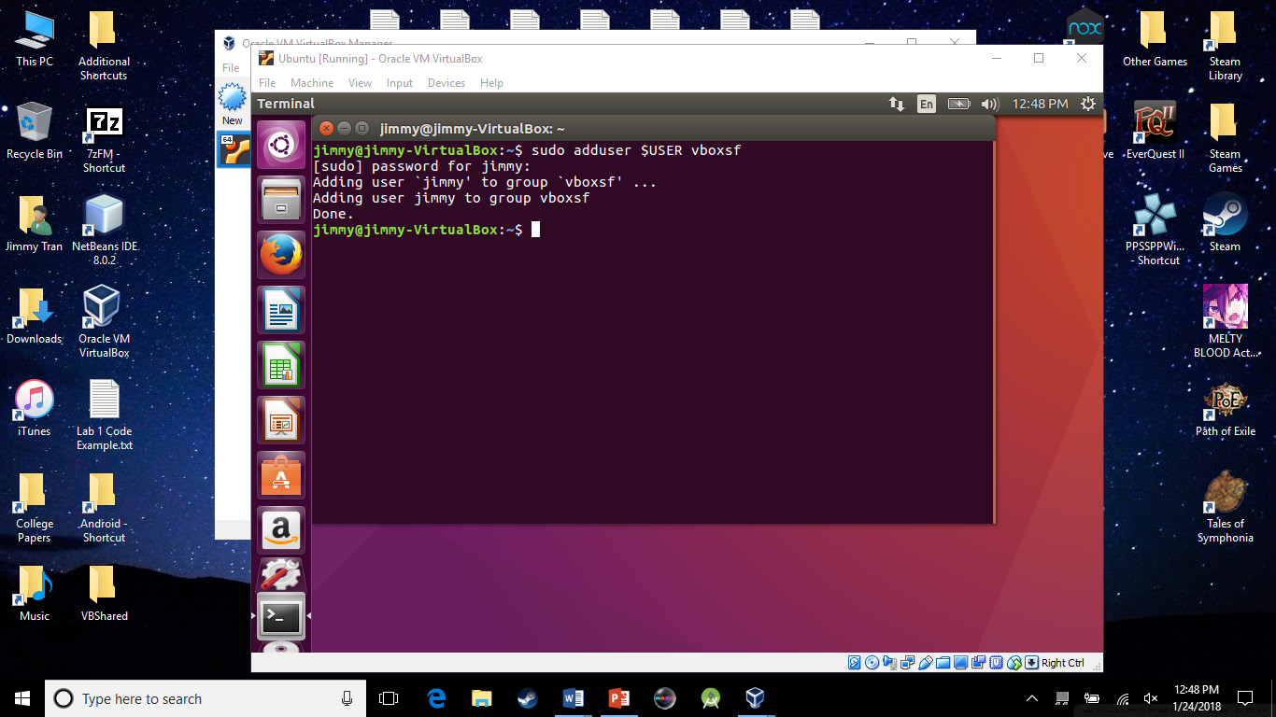

Part 2: Screenshot below for module loading and removing.

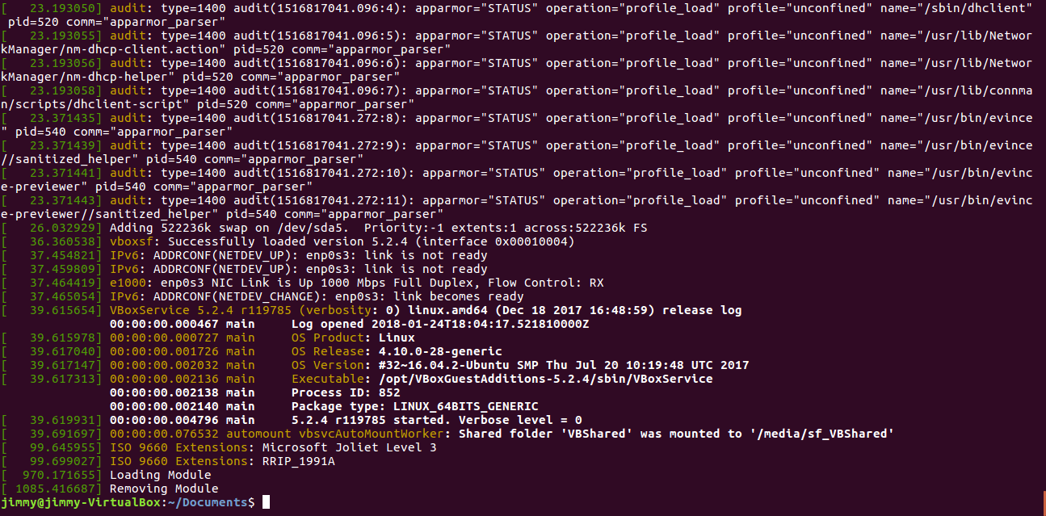

Part 3:

1 and 2) Screenshot for module load and removal combined . I know the years don’t make sense. Sue me for picking random numbers. It works in any case. The above loads and removes are there because I forgot the labels for the variables. Ignore those.

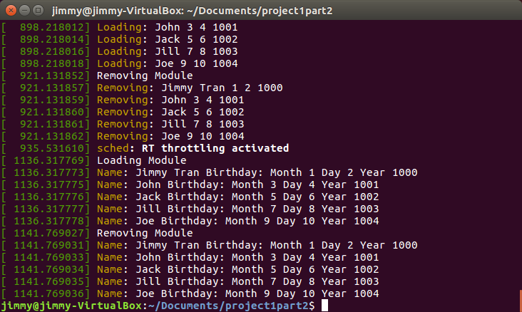

3) Source Code:

#include <linux/init.h>

#include <linux/module.h>

#include <linux/kernel.h>

#include <linux/list.h>

#include <linux/slab.h>

struct birthday

{

char *name;

int month;

int day;

int year;

struct list_head list;

};

/**

* The following defines and initializes a list_head object named birthday_list

*/

static LIST_HEAD(birthday_list);

int simple_init(void)

{

printk(KERN_INFO "Loading Module\n");

/* Create a linked list containing five struct birthday elements*/

/* NOTE:THE NAME OF FIRST STRUCT BIRTHDAY SHOULD BE YOUR OWN NAME */

struct birthday *person1;

struct birthday *person2;

struct birthday *person3;

struct birthday *person4;

struct birthday *person5;

//first element

person1=kmalloc(sizeof(*person1),GFP_KERNEL);

person1->name="Jimmy Tran";

person1->month=1;

person1->day=2;

person1->year=1000;

INIT_LIST_HEAD(&person1->list);

//second element

person2=kmalloc(sizeof(*person2),GFP_KERNEL);

person2->name="John";

person2->month=3;

person2->day=4;

person2->year=1001;

INIT_LIST_HEAD(&person2->list);

//third element

person3=kmalloc(sizeof(*person3),GFP_KERNEL);

person3->name="Jack";

person3->month=5;

person3->day=6;

person3->year=1002;

INIT_LIST_HEAD(&person3->list);

//fourth element

person4=kmalloc(sizeof(*person4),GFP_KERNEL);

person4->name="Jill";

person4->month=7;

person4->day=8;

person4->year=1003;

INIT_LIST_HEAD(&person4->list);

//fifth element

person5=kmalloc(sizeof(*person5),GFP_KERNEL);

person5->name="Joe";

person5->month=9;

person5->day=10;

person5->year=1004;

INIT_LIST_HEAD(&person5->list);

//build linked list

list_add_tail(&person1->list,&birthday_list);

list_add_tail(&person2->list,&birthday_list);

list_add_tail(&person3->list,&birthday_list);

list_add_tail(&person4->list,&birthday_list);

list_add_tail(&person5->list,&birthday_list);

/* Traverse the linked list */

struct birthday *ptr;

list_for_each_entry(ptr,&birthday_list,list){

/* on each iteration ptr points */

/* to the next birthday struct */

printk(KERN_INFO "Name: %s Birthday: Month %d Day %d Year %d\n",ptr->name,ptr->month,ptr->day,ptr->year);

}

return 0;

}

void simple_exit(void) {

/* Remove the elements from the linked list and return the free memory back to the kernel */

printk(KERN_INFO "Removing Module\n");

struct birthday *ptr,*next;

list_for_each_entry_safe(ptr, next, &birthday_list,list){

/* on each iteration ptr points */

/* to the next birthday struct */

printk(KERN_INFO "Name: %s Birthday: Month %d Day %d Year %d\n",ptr->name,ptr->month,ptr->day,ptr->year);

list_del(&ptr->list);

kfree(ptr);

}

}

module_init( simple_init );

module_exit( simple_exit );

MODULE_LICENSE("GPL");

MODULE_DESCRIPTION("Kernel Data Structures");

MODULE_AUTHOR("SGG");